Borehole No. GM69
Location Bongkrom,Afram Plains
Latitude N 06°57.963’
Longitude W000°34.114’
Date started --/01/2000
Date completed --/01/2000

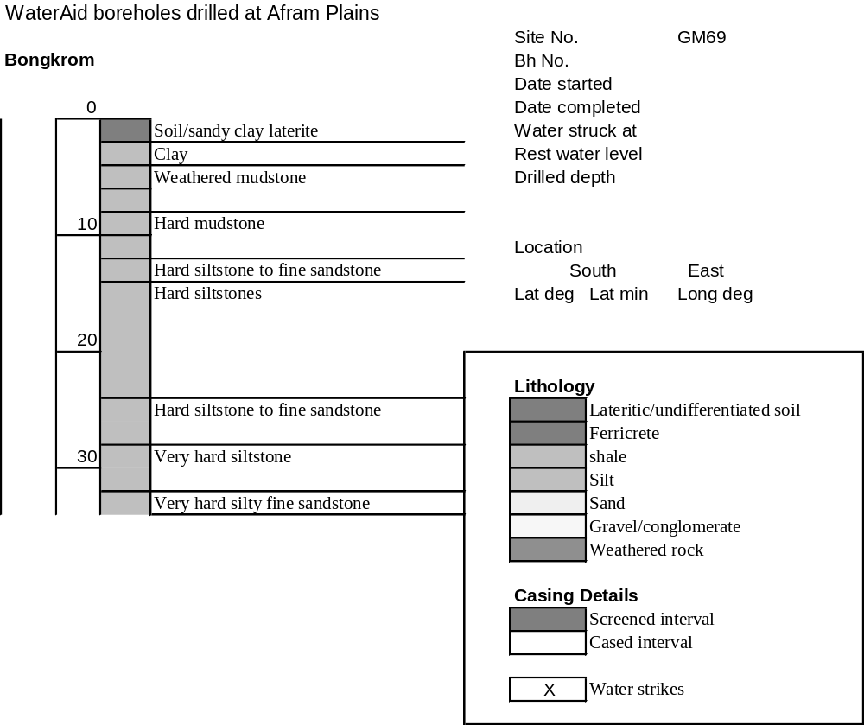

Summary Lithological Log
Depth(m)
From To
0 1 Soil/sandy clay laterite
1 2 Clay with ferricrete
2 3 Clay
3 7.1 Weathered mudstone
7.1 11.2 Hard mudstone
11.2 14.2 Hard siltstone to fine sandstone
14.2 24.4 Hard siltstones
24.4 28.4 Hard siltstone to fine sandstone
28.4 31.5 Very hard siltstone
31.5 34.5 Very hard silty fine sandstone

Detailed Lithological Log
Depth(m) Lithology
From To

Soil/sandy clay/laterite
0 1 Yellow ochre and grey sandy clay with concretions of sandy red and
orange very hard silcretised ferricrete.

Clay with ferricrete
1 2 Brown/light grey and orange clay with fragments of concretionary dark
red and brown ferricrete.

Clay
2 3 Light blue/green, ochre and orange kaolin clay

Weathered mudstone
3 4.1 Ochre/green weathered mudstones
4.1 5.1 Ochre green to brown/grey weathered mudstones
5.1 6.1 Soft grey and ochre green weathered mudstones
6.1 7.1 Grey compact mudstones with weathered brown partings

Hard mudstone
7.1 8.1 Dark green grey splintery hard mudstones with brown partings
8.1 9.1 Hard dark grey mudstones with brown partings
9.1 10.2 Hard dark grey mudstones some brown partings
10.2 11.2 Hard dark grey mudstone with odd fragment of soft ochre and brown
weathered mudstones

Hard siltstone to fine sandstone
11.2 12.2 Hard dark grey siltstone to fine grained sandstone with odd thin calcite
filled vein
12.2 13.2 Dark grey siltstone to fine grained hard sandstone
13.2 14.2 Dark grey siltstone to fine grained hard sandstone, with brown
weathering along joints

Hard siltstones
14.2 15.2 Dark green/grey hard siltstones
15.2 16.3 Dark green/grey hard siltstones
16.3 17.3 Dark green/grey hard siltstones
17.3 18.3 Hard dark grey to greenish grey siltstones
18.3 19.3 Hard dark grey to greenish grey siltstones
19.3 20.3 Hard dark grey to greenish grey siltstones
20 .3 21.3 Hard dark grey to greenish grey siltstones, with odd brown parting
21.3 22.4 hard dark green/grey siltstone; subordinate dark grey and orange very
hard streaked fine grained sandstone
22.4 23.4 Hard dark greenish grey siltstones
23.4 24.4 Hard dark greenish grey siltstones with odd fragment of dark
brown/grey mudstone

Hard siltstone to fine sandstone
24.4 25.4 Hard dark green/grey siltstone; subordinate dark grey and orange
streaked very hard fine grained sandstone
25.4 26.4 Very hard dark grey and orange streaked fine grained sandstone to
siltstone
  - 27.4 Hard dark green/grey siltstone and very hard streaked dark grey and
orange fine grained sandstones
  - 28.4 Very hard streaked dark grey and orange fine grained sandstone to
siltstone

Very hard siltstone
28.4 29.5 Hard dark green/grey silts; subordinate very hard streaked dark grey
and orange fine grained sandstones with odd thin calcite lined vein
29.5 30.5 Very hard dark grey siltstone with orange iron oxide lined cracks
30.5 31.5 Very hard dark grey siltstones
Very hard silty fine sandstone
31.5 32.5 Very hard dark grey silty fine grained sandstones
32.5 33.5 Very hard dark grey silty fine grained sandstones with odd interbedded
thin orange sandstone bands
  - 34.5 Very hard dark grey silty fine grained sandstones

